IMPLEMENT PRIM'S ALGORITHM
Code:
#include <stdio.h>

#define INF 999

int main()
{
int cost[10][10], visited[10] = {0};
int n, i, j, u, v, min, total = 0;

printf("Enter number of vertices: ");
scanf("%d", &n);

printf("Enter cost adjacency matrix:\n");

for(i = 0; i < n; i++)
{
for(j = 0; j < n; j++)
{
scanf("%d", &cost[i][j]);

if(cost[i][j] == 0)
cost[i][j] = INF;
}
}

visited[0] = 1;

printf("\nEdges in Minimum Spanning Tree:\n");

for(i = 0; i < n - 1; i++)
{
min = INF;

for(j = 0; j < n; j++)
{
if(visited[j])
{
int k;

for(k = 0; k < n; k++)
{
if(!visited[k] && cost[j][k] < min)
{
min = cost[j][k];
u = j;
v = k;
}
}
}
}

printf("%d - %d = %d\n", u, v, min);
total += min;
visited[v] = 1;
}

printf("Minimum Cost = %d\n", total);

return 0;
}
OUTPUT:
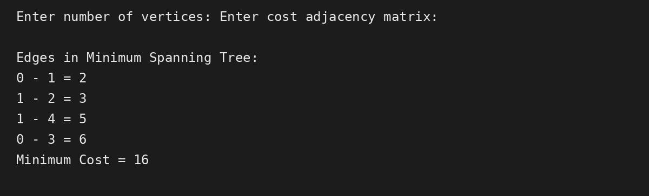

Conclusion:
Complexity | Value
Time Complexity | O(V²)
Space Complexity | O(V²)

